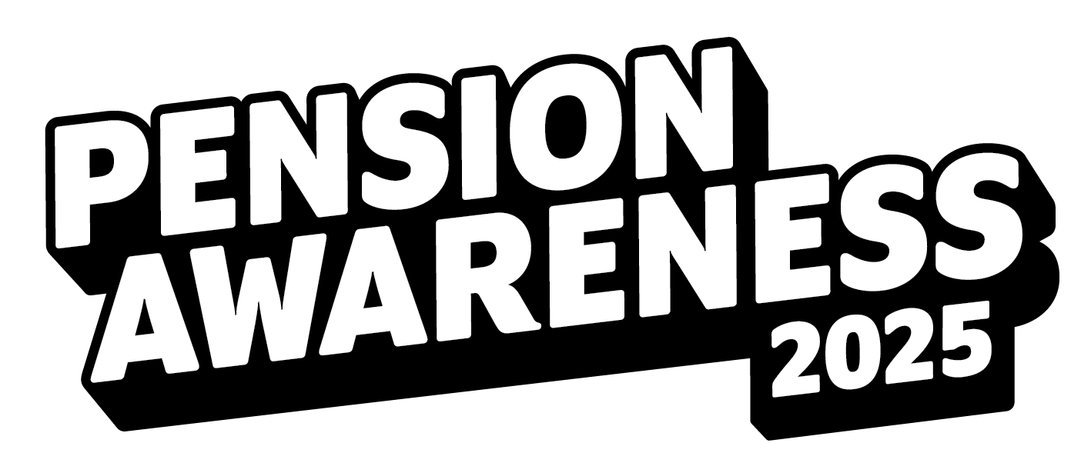

**Get ready to take on the Pensions Challenge!**

**Pension Awareness is coming – are you ready? 15–17 September**

Mark your calendars — **Pension Awareness** is landing from **15 to 17 September**, and it’s going to be fun, informative, and all about you and your future!

To get you warmed up, we’ll be dropping a **6-Step Pension Challenge Checklist** in the run-up to the big event. It’s quick, simple, and a great way to tick off some important pension to-do’s (bonus points if you do it with a cuppa in hand).

Then the real fun begins. For three whole days, we’re going live with our **interactive TV shows**, each one diving into a different money and pension topic. Expect expert guests, real-talk, and answers to the questions you want answers to!

So, whether you’re just getting started or fine-tuning your retirement plans, there’s something for everyone. Head to our [website](https://pensionawarenessday.com/) to take a look at our schedule of live shows, or get a head start by diving into the knowledge centre.

Save the date. Take the challenge. Join the shows. And let’s get to grips with our pensions — together!