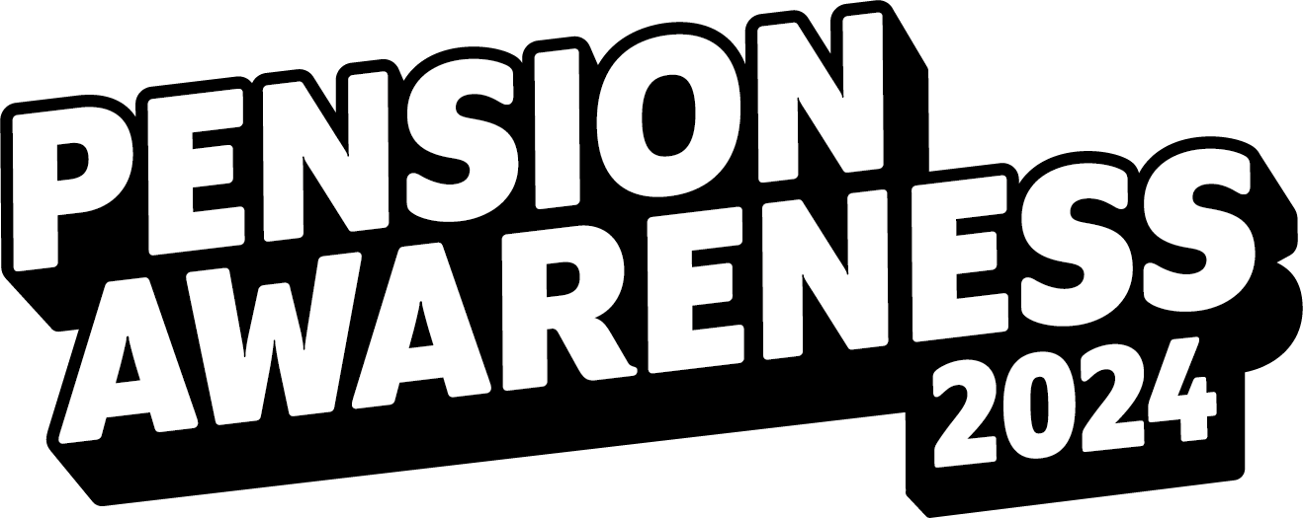

**Let’s do this together**

It’s that time of year again. Pension Awareness is back for 2024, with more of the live shows,

online content, and pension problem-solving you know and love.

This year, Pension Awareness Week will run from the 9th-13th September - with our live shows taking place between **10th-12th September**.

You’ll get to learn to love your pension better than ever. You’ll know it like the back of your

hand, and when the week is over, you’ll be as prepared as you’ve ever been. What’s not to

like?

Pension Awareness brings 3 solid days of online live shows straight to your workplace, living room, kitchen, and – as we’ve been told many times before - bathroom (basically wherever your screen of choice can be taken).

We break jargon-juiced money topics into simple bite sized chunks to help you take control

of your retirement – whenever it may be – like never before. And once it’s all over, you’ll be eating pensions for breakfast.

Expect a trove of online content to peruse while you wait for us to go live, too. Articles and

guides that go into detail, video explainers, and handy resources are just the tip of the

iceberg.

Of course, we cover things like how much is enough, combining pots, Defined Benefit, and ways you can withdraw your pension when it’s time to hang up the gloves.

But it doesn’t stop there.

It’s a many-layered show we have here. We look at financial wellbeing. Budgeting. Debt. You

name it. Pension Awareness 2024 goes live on the 10th September. It’s completely free, and it’s completely fun.

To find out more, [head on over to our website](https://pensionawarenessday.com/), where you’ll be able to sign up for as many

live shows as you can muster, as well as surf the wave of articles and videos.

We’ll also be uploading every live show to our on-demand catchup service this year, so stay

on the lookout for shows you can’t attend after the event.

We can’t wait to welcome you to Pension Awareness 2024. It’s gonna be fun.