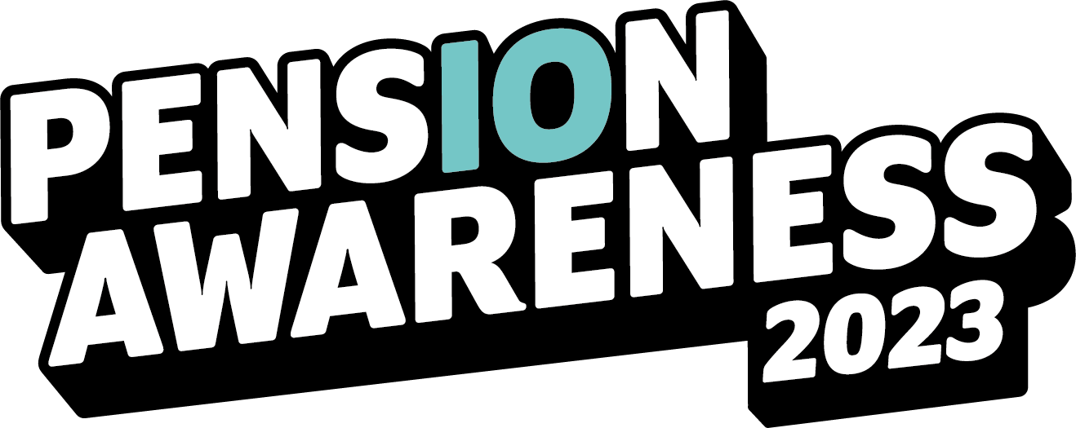

Take charge of your pension

It’s that time of year again, yes, Pension Awareness is back. Bigger than ever. Better
than before. And it’s been a decade of difference. 2023 marks the tenth anniversary of
Pension Awareness, and this year’s iteration runs from the 11th-15th September.

What if I said you could get to know your pension better than ever and prepare for the
future you want? All in the simplest way, too.

The brainchild of Pension Geeks (champions of all that is retirement), Pension
Awareness sets up a week of online live shows that break down the most jargon-juiced
topics and confusing questions into bite-sized chunks. You’ll be eating pensions for
breakfast come September.

Alongside the live shows are a host of articles, videos, and resources. You’ll have an
arsenal of knowledge covering the State Pension, contributions, combining multiple
pension pots, and how to eventually take your hard-earned money. And that’s just the
tip of the iceberg.

Because it doesn’t stop with pensions. Oh no. Pension Awareness has evolved into an
all-encompassing ensemble event. Financial wellbeing, budgeting, mindful money, you
name it; we got it. Within reason.

Pension Awareness kicks off on Monday 11th September, and you can bet it’s gonna
be a good one. It’s free to attend and absolutely everyone is welcome!

To find out more, jump onto our website. Here, you’ll easily be able to register for as
many live online shows as you like from the end of July. Plus, you can surf across a trove of
articles and videos or catch up on last year’s event via on-demand streaming.

